Herrmann Zendesk End User Guide
Rev. 1

Contents
Creating an Account 3
Step 1 – Access the Herrmann Help Center 3
Step 2 – Access The Login Tool 3
Step 3 – Verify Your New Account 5
Submitting a Support Request 6
Step 1 – Access the Support Form 6
Step 2 – Filling out the Support Request Form 6
Checking the Status of a Submitted Request 7
Step 1 – Access My Activities 7
Step 2 – My Requests 7
Step 3 – Request Detail Page 8

Creating an Account
Before submitting tickets and requests via Herrmann Zendesk, it is recommended to create an account. Creating an account with Herrmann Zendesk has several benefits that allow intuitive tracking of submitted requests:
- Users can track the status of their request
- Users can respond to communications from support staff
- Users can see all prior communications with support staff in one place
- Users will have access to specially curated sections of the Herrmann Help Center

Step 1 – Access the Herrmann Help Center
This can be done by entering the following URL into the URL bar:
- https://herrmann.zendesk.com/hc/en-us
Alternatively, the Herrmann Help Center can be reached via the Herrmann International Contact Us page.

Step 2 – Access The Login Tool
Once on the Herrmann Help Center, users can access the login tool by clicking the ‘Sign In’ link at the top right of the page.
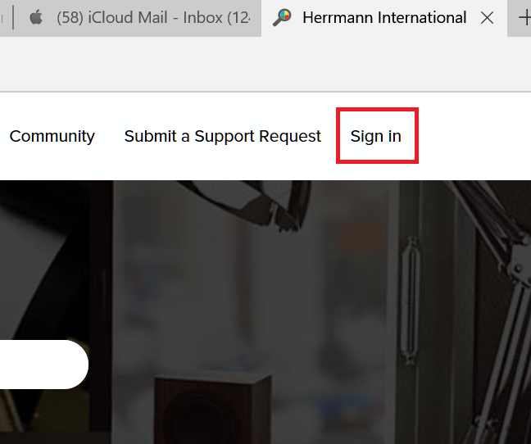

After clicking the ‘Sign In’ link’ the login tool will display. The login tool allows users to either sign in if they have an existing Herrmann Zendesk account or create a new one. In order to create a new Herrmann Zendesk account, click the ‘Sign Up’ link.
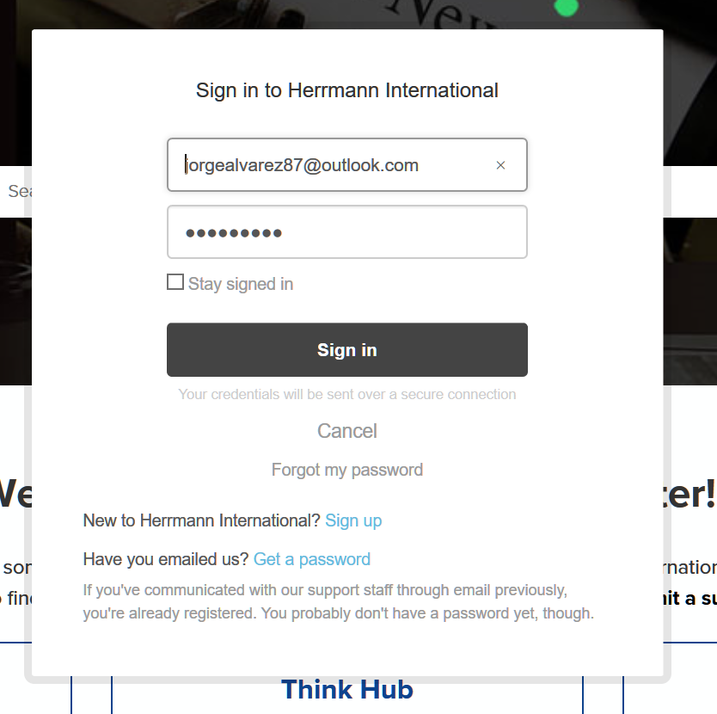
Clicking on the ‘Sign Up’ link opens the below window. Fill in the required information and click the checkbox next to ‘I’m Not a Robot’. This will run a quick validation check. Once the validation check completes, click on the ‘Sign up’ button at the bottom of the window.
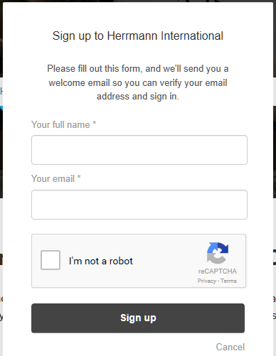

Step 3 – Verify Your New Account
After signing up for Herrmann Zendesk, a verification email will be sent to the email address that the user signed up with. The email contains a verification link to ensure that the user of the email address is in fact the person that requested the login credentials.
In addition, the link will lead the user to create a password for the account. Verify that the name displayed in the ‘Your name’ field is correct and enter a password that meets the Password Requirements displayed. After entering the desired password, click on the ‘Set password’ button to continue. The user is now signed up and logged into the Herrmann Help Center.
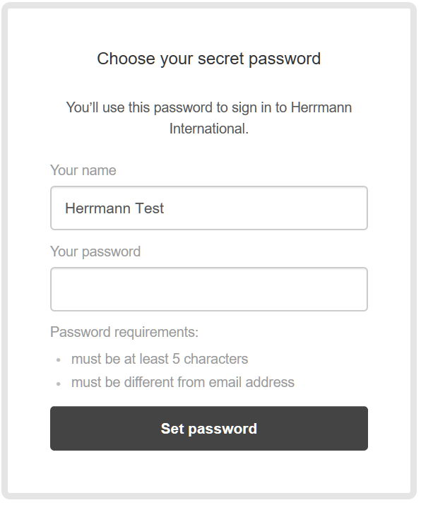

Submitting a Support Request
Whether they are logged in or not, users can submit Support Requests via the Herrmann Help Center’s Support Request Form. On the Support Request Form, users will have multiple fields to populate with information related to the issue they are facing.

Step 1 – Access the Support Form
To access the support form, click on the ‘Submit a Support Request’ link that is present in two places on the Herrmann Help Center. One of these links is located at the top of each page of the Herrmann Help center near the user’s name and photo:
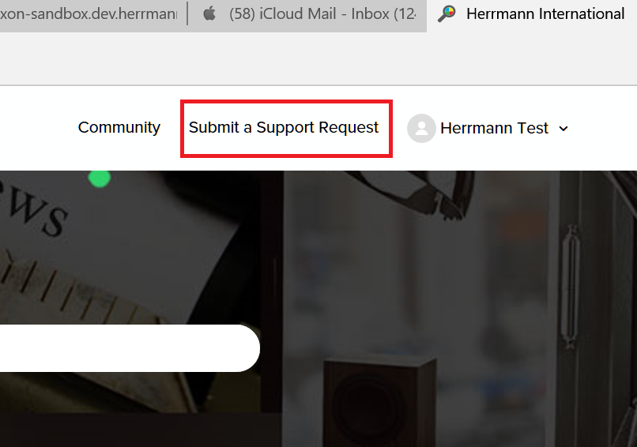
The other link is located underneath the ‘Welcome to the Herrmann Help Center!’ welcome message.

Step 2 – Filling out the Support Request Form
Once users click on the ‘Submit a Support Request’ link, they will be taken to the Support Form. Fill out each of the Support Form fields.
These fields include:
- CC (available only if logged in) – Carbon Copy (CC) an email to receive a copy of the submitted Support Request
- Your Name – the name of the user submitting the request
- What are you having an issue with? – allows the user to choose from a selection of Herrmann platforms based on the issue their issue
- Subject – a one sentence summary of the issue
- Description of the Issue – a more detailed description of the user’s issue
- Internet Browser – a selection of Internet browsers the user can choose from depending on which one they used when the issue occurred
- Version of Browser – an optional field where the user can note which version of the browser they used when the issue occurred
- Attachments – an option field where users can attach files related to their issue
Once the fields have been filled out, click on the ‘Submit’ button to send the Support Request to the Herrmann Support Staff for their review and action.

Checking the Status of a Submitted Request
If logged in, users can check the status of a submitted Request in addition to Requests that they have been CC’d on.

Step 1 – Access My Activities
To access the My Activities section of the Help Center, click on the user’s name and photo located in the top righthand corner of any page on the Herrmann Help Center. This will open up a menu with several links including ‘My Activities’. Click on the ‘My Activities’ link.
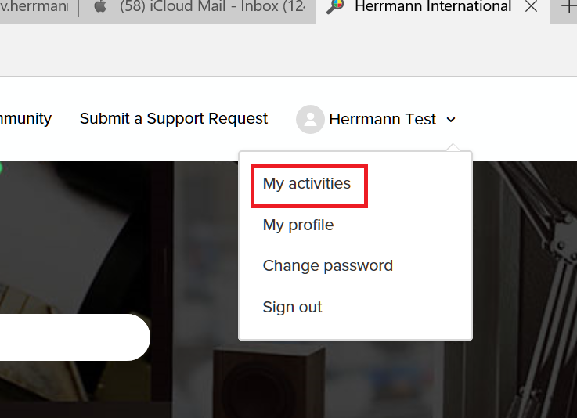

Step 2 – My Requests
By default, the displayed page in the My Activities section will be My Requests. This page displays all the requests that a user has submitted to the Herrmann Help Center in addition to the below information:
- Subject
- Ticket ID
- Time Created
- Time of Last Activity
- Status
To see a detailed status of a ticket, click on the ticket subject.
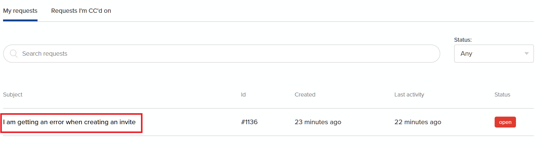

Step 3 – Request Detail Page
After clicking on the Request subject, the user is taken to a page with more detail on the Request status. The user can see additional fields in addition to any communications between the user and Herrmann Support Staff.
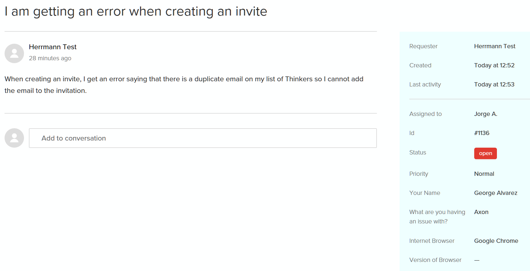
In addition to checking the status of a Request, users can use the ‘Add to conversation’ field to communicate with Herrmann Staff. Type the message into the field. Users can also add attachments as well using the attachment tool below the conversation box. Finally, users can add emails to CC using this tool as well. Click the ‘Submit’ button to send the message to Herrmann Support Staff.
